The calculations for the dynamic model are mostly built on “Modeling and Simulation of the LAUV Autonomous Underwater Vehicle” written by Jorge Estrela da Silva, Bruno Terra, Ricardo Martins and Joao Borges de Sousa.

The dynamic model consists of the required matrixes and functions to describe the AUV’s dynamic response when sailing a mission. The dynamic model is a solution to the following equation

$$\dot{x}= \left[\begin{matrix}\dot{v} \\ \dot{ƞ}\end{matrix}\right]=A⋅\left[\begin{matrix}v \\ ƞ\end{matrix}\right]+ B⋅τ$$

Where

$$A=\left[\begin{matrix} M^{-1}\left[-C(v)-D(v)-L(v)\right] & -M^{-1}G(ƞ) \\ J(ƞ) & 0\end{matrix}\right]$$

and

$$B= \left[\begin{matrix}M^{-1} \\ 0\end{matrix}\right]$$

The model responds to change in the velocity and position components, which are

$v= \left[\begin{matrix}u \\ v \\ w \\ p \\ q \\ r\end{matrix}\right] \begin{matrix}surge \\ sway \\ heave \\ roll \\ pitch\end{matrix}$ and $ƞ= \left[\begin{matrix}x \\ y \\ z \\ ϕ \\ θ \\ ψ\end{matrix}\right]$

Where each of the parameters is as described in “Modeling and Simulation of the LAUV Autonomous Underwater Vehicle”, most of the values for the matrixes are taken from the same report but some are gotten from Simulink model made by Valur Einarsson in 2003 for the Gavia AUV. The $M$ is the constant inertia and the added mass matrix of the AUV, $C(v)$ is the Coriolis centripetal matrix, $D(v)$ is the damping matrix, $L(v)$ is the lift matrix $G(ƞ)$ is the matrix of resorting forces. The $M^{-1}$ matrix is the numeric invers of M where

$$M= \left[\begin{matrix}\begin{matrix}m-X_{\dot{u}} & 0 & 0 \\ 0 & m-Y_{\dot{v}} & 0 \\ 0 & 0 & m-Z_{\dot{w}}\end{matrix} & \begin{matrix}0 & mz_{G} & 0 \\ -mz_{G} & 0 & 0 \\ 0 & 0 & 0\end{matrix} \\ \begin{matrix}0 & -mz_{G} & 0 \\ mz_{G} & 0 & 0 \\ 0 & ö & 0\end{matrix} & \begin{matrix}I_{x}-K_{\dot{p}} & 0 & 0 \\ 0 & I_{\dot{q}} & 0 \\ 0 & 0 & I_{\dot{z}}-N_{\dot{r}}\end{matrix}\end{matrix}\right]$$

The matrix of resorting forces $G(ƞ)$ was simplified as the center of buoyancy and center of mass for the Gavia where estimated to be in the center of Gavia’s coordinates, $z_{B}=x_{G}=x_{B}=y_{G}=y_{B}=0$, except for a small offset of the center of gravity in z direction $z_{G}=0.1$. The resulting resorting force matrix is

$$G\left(ƞ\right)= \left[\begin{matrix}0 & 0 & 0 & 0 & W-B & 0 \\ 0 & 0 & 0 & -(W-B) & 0 & 0 \\ 0 & 0 & 0 & 0 & 0 & 0 \\ 0 & 0 & 0 & z_{G} & 0 & 0 \\ 0 & 0 & 0 & 0 & z_{G}W & 0 \\ 0 & 0 & 0 & 0 & 0 & 0\end{matrix}\right]$$

$W$ is the weight and $B$ is the buoyancy of the Gavia.

The force vector $τ$ had to be calculated and modified for the Gavia, it consists of the product of the matrix K and an input vector from the Gavia rudders angle of attack ($α$) and the RPM ($δ_{n}$) of the propeller.

$$K= \left[\begin{matrix}K_{prop} & -0_{drag} & -0_{drag} & -0_{drag} & -0_{drag} \\ 0 & F_{lift} & F_{lift} & 0 & 0 \\ 0 & 0 & 0 & F_{lift} & F_{lift} \\ 0 & 0_{roll} & 0_{roll} & 0_{roll} & 0_{roll} \\ 0 & 0 & 0 & {-x_{r}F}_{lift} & -x_{r}F_{lift} \\ 0 & -{x_{r}F}_{lift} & -x_{r}F_{lift} & 0 & 0\end{matrix}\right]$$

The input vector is

$$input= \left[\begin{matrix}1 \\ α_{r_UR} \\ α_{r_LR} \\ α_{r_RP} \\ α_{r_LP}\end{matrix}\right]⋅{δ_{n}}^{2}$$

The result is each of the force and moment components in x, y and z

$$τ= \left[\begin{matrix}X_{τ} \\ Y_{τ} \\ Z_{τ} \\ K_{τ} \\ M_{τ} \\ N_{τ}\end{matrix}\right]=K⋅input$$

The calculation for the force on Gavia’s rudders is based on Helgi masters thesis (see page….) where the angle of attack is as can be seen in figure 1. The angle of attack produces a force $F_{lift}= \frac{1}{2}ρAr_{blade}^{2}2π$ and the propeller produces a force $K_{prop}= \frac{1}{2}ρAc_{L}\left(α\right)r_{blade}^{2}$. The airfoil area (A) and the propeller force ($K_{prop}$) are estimated as in Helgi’s master thesis where $K_{prop}=95⋅{10}^{-6}$. Forces that produce roll and drag on the Gavia are neglected.

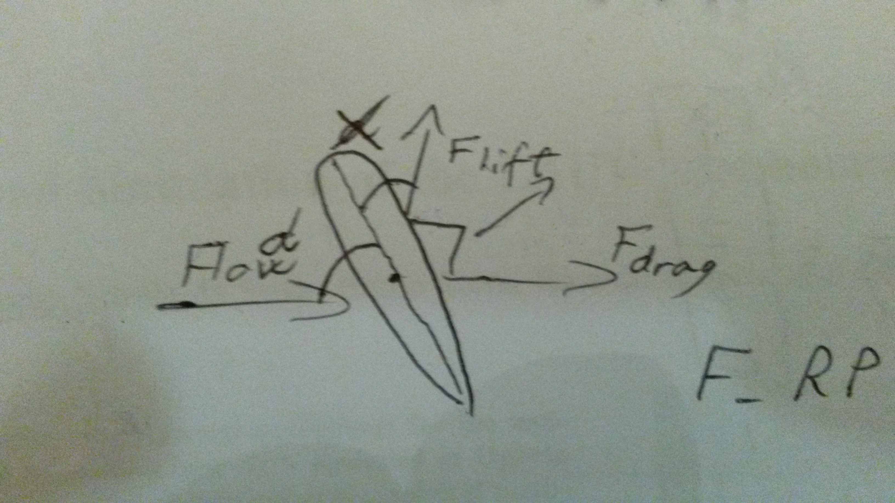

Figure : Angle of attack for the rudders.

The names of the corresponding rudders are as shown in figure 2

* Upper rudder => r_UR
* Lower rudder => r_LR
* Right rudder => r_RP
* Left rudder => r_LP

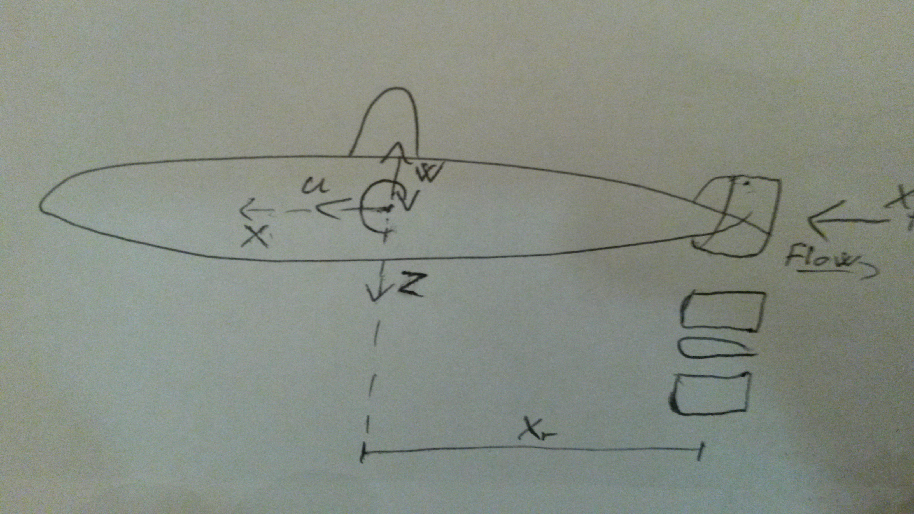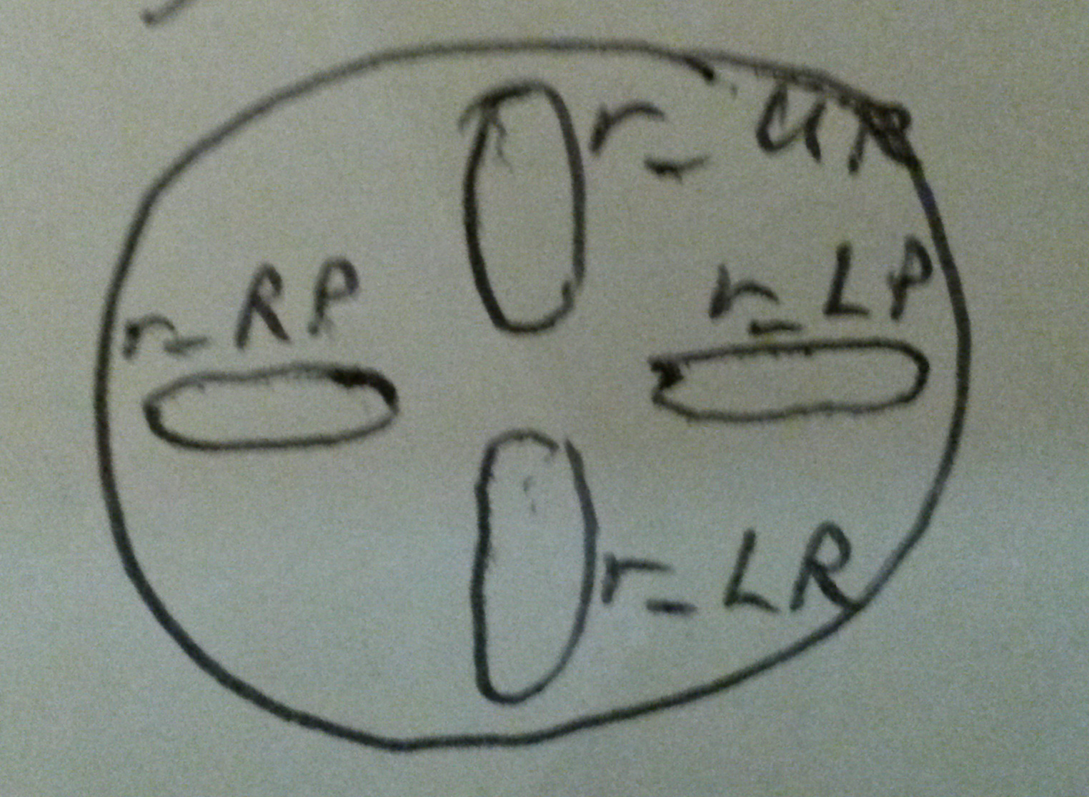

Figure : Position of rudders shown.

The dynamic model is written in C++ and depends on Boost 1.56 C++ libraries

Example of usage 